<html> <head><title>interdependent menus</title></head>
<body>
<form name="my_form">
<select name="my_groups" size="4" onChange="updategroups(this.selectedIndex)" style="width: 150px">
<option selected>Select a topic</option>
<option value="food">food and drink</option>
<option value="sports">sports</option>
<option value="books">good books</option>
</select>

<select name="sub_groups" size="4" style="width: 150px" onClick="alert(this.options[this.options.selectedIndex].value);"> /select>
</form>
<script language="javascript" type="text/javascript">
<!--
var countrieslist=document.my_form.my_groups;
var groupslist=document.my_form.sub_groups;
var groups=new Array();

groups[0]=""; // erase all current values in the list
groups[1]=["pizza and beer|pizzabeervalue", "hamburger and fries|burgerfriesvalue", "salad|saladvalue"];
groups[2]=["nhl hockey|hockeyvalue", "cfl football|footballvalue", "pga golf|golfvalue", "tour de france cycling|cyclingvalue"]
groups[3]=["paddle to the arctic|paddlevalue", "as far as my feet will carry me|feetvalue", "training a tiger|tigervalue", "two survived|survivedvalue", "66 days adrift|adriftvalue"]

function updategroups(selectedgroup){
groupslist.options.length=0; // erase the existing array

if (selectedgroup>0) {
for (i=0; i<groups[selectedgroup].length; i++) {
groupslist.options[groupslist.options.length] =
new Option(groups[selectedgroup][i].split("|")[0], groups[selectedgroup][i].split("|")[1])
}
}
}
// -->
</script></body></html>

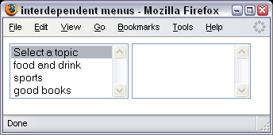 | 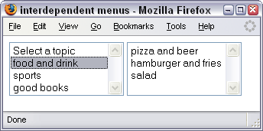
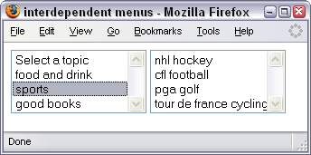 | 